#a function for the (negative) of the reduced log-likelihood  
rllik <- function(x){  
 -(log(.5*(1/(1+x^2)+ x^2/((1+x^2)^2*(1+x^2-(x^2/(1+x^2)))))) + .5*(log(1+x^2+x^4)))  
}

#a plot of the reduced log-likelihood  
thetas <- seq(0,5, length=1000)  
lliks <- rllik(thetas)  
plot(lliks~thetas, type="l", xlab=expression(theta) , ylab="reduced log-likelihood")

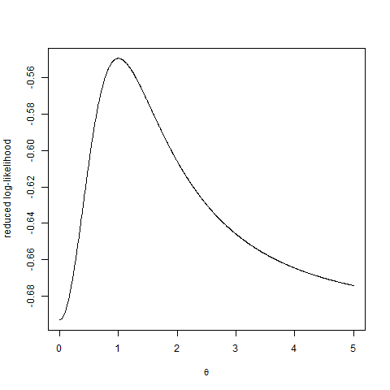

#minimizing the negative log-likelihood for theta  
optim(par=1, fn=rllik, method="Brent", lower=0, upper=10)$par

## [1] 1

#a function to get sigma^2 estimate  
sig2 <- function(x){  
 .5*(1/(1+x^2)+ x^2/((1+x^2)^2*(1+x^2-(x^2/(1+x^2)))))  
}  
sig2(1)

## [1] 0.3333333